Question 1.
Create a Node.js application using ES6 features. Develop a module mathUtils.js that defines functions for addition and subtraction using arrow functions. Use const and let appropriately and include default parameters. Export these functions using ES6 module syntax.
In another file app.js, import the module and display the results in the console.
CODE:
- Package.json
{
"name": "q1",
"version": "1.0.0",
"description": "",
"main": "index.js",
"type": "module",
"scripts": {
"test": "echo \"Error: no test specified\" && exit 1"
},
"keywords": [],
"author": "",
"license": "ISC"
}
- mathUtils.js
const add = (a = 0, b = 0) => { return a + b;};
const subtract = (a = 0, b = 0) => { return a - b;};
const multiply = (a = 1, b = 1) => { return a * b;};
const divide = (a = 1, b = 1) => { return a / b;};
export { add, subtract, multiply, divide };
- app.js
import { add, subtract, multiply, divide } from "./mathUtils.js";
let num1 = 20;
let num2 = 10;
const addition = add(num1, num2);
const subtraction = subtract(num1, num2);
const multiplication = multiply(num1, num2);
const division = divide(num1, num2);
console.log("Addition:", addition);
console.log("Subtraction:", subtraction);
console.log("Multiplication:", multiplication);
console.log("Division:", division);

OUTPUT:
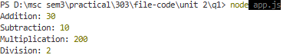
Question 2.
Write a Node.js program that fetches data from an external API using the built-in fetch (Node.js v18+). Use async/await to handle asynchronous operations and implement proper error handling using try/catch.
Display selected fields (e.g., name and email) from the API response in the console.
CODE:
const url = "https://jsonplaceholder.typicode.com/users";
async function getUsers() {
try {
const response = await fetch(url);
if (!response.ok) {
throw new Error(`HTTP Error: ${response.status}`);
}
const data = await response.json();
data.forEach(user => {
console.log("Name:", user.name);
console.log("Email:", user.email);
console.log("----------------");
});
} catch (error) {
console.log("Error:", error.message);
}
}
getUsers();
OUTPUT:
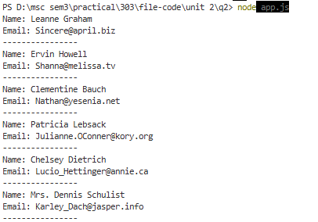
Question 3.
Develop a Node.js REST API using Express and ES6 syntax. Create a GET endpoint /user that accepts query parameters name and age.Validate that age is greater than 18, If valid, return a JSON response with a welcome message ,If invalid, return an appropriate error message with HTTP status code
CODE:
const express = require("express");
const app = express();
app.get("/user", (req, res) => {
const name = req.query.name;
const age = parseInt(req.query.age);
if (!name || isNaN(age)) {
return res.status(400).json({message: "Please provide valid name and age"});
}
if (age <= 18) {
return res.status(400).json({message: "Age must be greater than 18"});
}
res.json({message: `Welcome ${name}`,age: age});
});
const PORT = 3000;
app.listen(PORT, () => {console.log(`Server running on port ${PORT}`);});
OUTPUT:
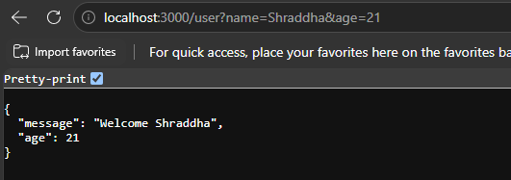
Question 4.
Create a Node.js program using modern ES6 features such as arrow functions, default parameters, and const/let. Configure Babel in your project and transpile the ES6 code into ES5.
Show: Original ES6 code ,Transpiled ES5 output ,Brief explanation of how Babel converts the code
CODE:
Src/app.js:
const greet = (name = "Student") => { return `Hello, ${name}!`;};
let number = 10;
const square = (n = 1) => { return n * n;};
console.log(greet("Shraddha"));
console.log("Number:", number);
console.log("Square:", square(number));
then after that run:
src/app.js:
- node src/app.js
then for babel:
- npx babel src --out-dir dist
- node dist/app.js
STRUCTURE:
q4/
│
├── src/
│ └── app.js
│
├── dist/
│ └── app.js
│
├── babel.config.json
├── package.json
├── package-lock.json
└── node_modules/
OUTPUT:
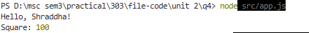
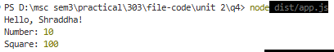
Question 5.
Develop a Node.js application using Express and EJS templating engine. Create a route /dashboard that renders a dynamic HTML page.Define a list of users in the server,Pass the data to the EJS template,Display the user details dynamically using EJS syntax
CODE:
- app.js
import express from "express";
const app = express();
app.set("view engine", "ejs");
const users = [
{id: 1,name: "Riya",email: "riya@gmail.com",age: 21},
{id: 2,name: "Amit",email: "amit@gmail.com",age: 22},
{id: 3, name: "Shraddha",email: "shraddha@gmail.com",age: 21}
];
app.get("/dashboard", (req, res) => { res.render("dashboard", { users: users});});
const PORT = 3000;
app.listen(PORT, () => { console.log(`Server running on port ${PORT}`);});

- Dashboard.ejs:
<!DOCTYPE html>
<html>
<head>
<title>User Dashboard</title>
</head>
<body>
<h1>User Dashboard</h1>
<% users.forEach(user => { %>
<div>
<h2><%= user.name %></h2>
<p>ID: <%= user.id %></p>
<p>Email: <%= user.email %></p>
<p>Age: <%= user.age %></p>
</div>
<% }); %>
</body>
</html>

- Package.json:

{
"name": "q5",
"version": "1.0.0",
"description": "",
"main": "app.js",
"type": "module",
"scripts": {
"test": "echo \"Error: no test specified\" && exit 1"
},
"keywords": [],
"author": "",
"license": "ISC",
"dependencies": {
"ejs": "^6.0.1",
"express": "^5.2.1"
}
}

- STRUCTURE:
q5/
│
├── node_modules/
│
├── views/
│ └── dashboard.ejs
│
├── app.js
├── package.json
└── package-lock.json
OUTPUT:
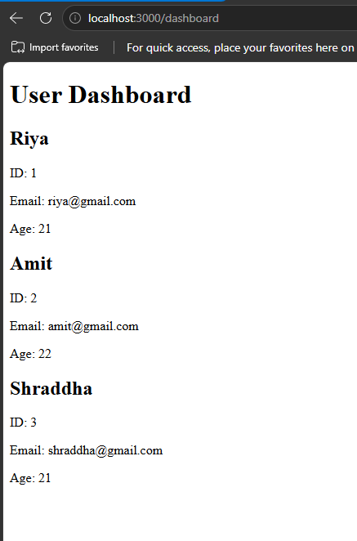
Question 6.
Create a complete Node.js application that includes:,A REST API endpoint /api/users returning JSON data, A route /dashboard that fetches this data internally and renders it using EJS,Use ES6 syntax throughout the application,Implement basic validation and error handling
CODE:
- Package.json
{
"name": "q6",
"version": "1.0.0",
"description": "",
"main": "index.js",
"type": "module",
"scripts": {
"test": "echo \"Error: no test specified\" && exit 1"
},
"keywords": [],
"author": "",
"license": "ISC",
"dependencies": {
"ejs": "^6.0.1",
"express": "^5.2.1"
}
}
- App.js
import express from "express";
const app = express();
app.set("view engine", "ejs");
const users = [
{id: 1,name: "Riya",email: "riya@gmail.com",age: 21},
{id: 2,name: "Amit",email: "amit@gmail.com",age: 22},
{id: 3,name: "Shraddha",email: "shraddha@gmail.com",age: 21}
];
app.get("/api/users", (req, res) => {
if (!users || users.length === 0) {
return res.status(404).json({message: "No users found"});
}
res.json(users);
});
app.get("/dashboard", async (req, res) => {
try {
const response = await fetch("http://localhost:3000/api/users");

if (!response.ok) {throw new Error("Failed to fetch users");}
const data = await response.json();
res.render("dashboard", {users: data});
} catch (error) {
console.log("Error:", error.message);
res.status(500).send("Error loading dashboard");
}
});
const PORT = 3000;
app.listen(PORT, () => {console.log(`Server running on port ${PORT}`);});
- Dashboard.js
<!DOCTYPE html>
<html>
<head>
<title>User Dashboard</title>
</head>
<body>
<h1>User Dashboard</h1>
<% if (users.length === 0) { %>
<p>No users found.</p>
<% } else { %>
<% users.forEach(user => { %>
<div>
<h2><%= user.name %></h2>
<p>ID: <%= user.id %></p>
<p>Email: <%= user.email %></p>
<p>Age: <%= user.age %></p>
</div>
<% }); %>
<% } %>
</body>
</html>

STRUCTURE:
q6/
│
├── views/
│ └── dashboard.ejs
│
├── app.js
└── package.json
OUTPUT:
